Day 18: 07-11-2025:

Web Service: Service for web application when more than one application running using different technologies.
Amazon - Spring boot
Payment -- Paytm java
Phone Pay python
Gpay php
Net banking express js
Credit card asp.net
--java request ----

App1 XML/JSON App2
Java Python

----python response ----

XML : eXtensible markup of language
JSON : JavaScript object notation

XML format

Emp - object
<Employee>
<Id>100</Id>
<Name>Raj</Name>
<Salary>12000</Salary>
</Employee>

JSON
{“id”:100,”name”:”Ravi”,”Salary”:12000}
RMI : remote method invocation
2 types of web service
- SOAP Web Service
Simple Object Access Protocol
In SOAP web service we can consume and produce data only in the form of XML.
SOAP Web service base upon SOA. Service Oriented architecture.

SB
WSDL :
Web service description language
Type of xml file
SC SP
SOAP req/res Method or function

Python Java

Search wsdl file from broker and generate the code using WSDL file with respective language and call service.

Limitation of SOAP Web Service
- We can consume and produce data only in the form of XML with SOAP Structure.

- REST full web service

In Rest full web service : Representation state transfer. In Rest Full Web service we expose our server side resource like Servlet, JSP or Spring controller as web service. Using Rest Full web service we can consume and produce data in any format base upon client requirement. Like html, plain text, json, xml or any other mediate type.
Rest full web service not a standard. It is style expose our resource as web service.

Java point of view
JAX_WS : Java API for XML web service
Axios, metro tools we were using to implements SOAP web service using Java technologies.
JAX_RS : java API for XML Restfull web service
To implements rest full web service
Jersey tool --- Servlet API to make rest API
Spring framework/ Spring boot -

Web Starter -
@Controller
public class MyController {
@RequestMapping(value=”say”,method=ReqeustedMethod.GET,produce=MediateType.PLAIN_TEXT)
public @ResponseBody String sayHello() {
return “Welcome to Rest API”;
}
}

}

@RestController // @Controller + @ResponseBody
public class MyController {
@RequestMapping(value=”say”,method=ReqeustedMethod.GET,produce=MediateType.PLAIN_TEXT)
public String sayHello() {
return “Welcome to Rest API”;
}
}

}

If we use normal controller with @Controller then our view must be html, or jsp or thymeleaf or any java view technologies.

If we make normal controller as rest controller using
@Controller + @ResponseBody
@RestController
Then view can be any technologies. Like
Java, .net, php, python, angular, react js or any rest client can call our application.

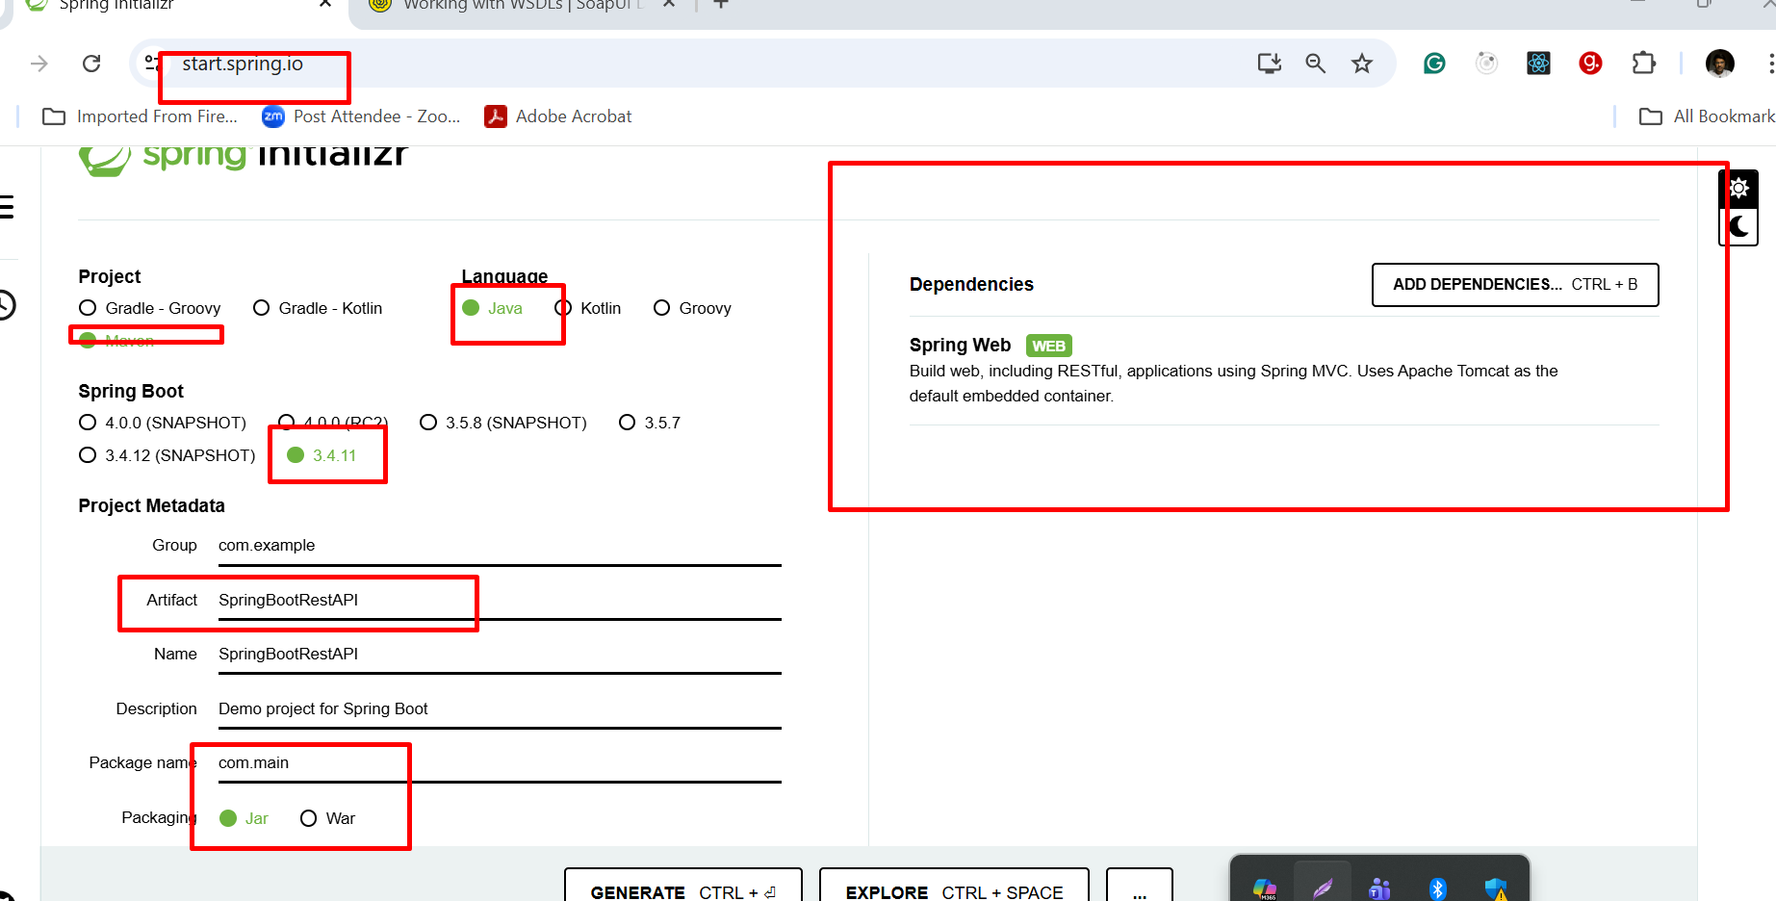

By default, @SpringBootApplication scan current package as well as sub package of current package.

Creating REST API for Product entity or Java Bean or POJO class

Get Method : get the resources like product, customer, order or account in json or xml format.
If we connect to db : select clause

Search the data. Below 2 technique we use to pass the data to rest api while calling using get method

Select with where clause
- Query param
URL?key=value passing one information
URL?key=value&key=value multiple value

- Path param
URL/value1 passing one information
URL/value1/value2 passing more than one value

Post Method :
Create the resource means store the data in collection, in database like mysql or mongo db.
Like insert query
In post method we need to pass the data through body of request in the form of xml or json.

Testing post method using post man client

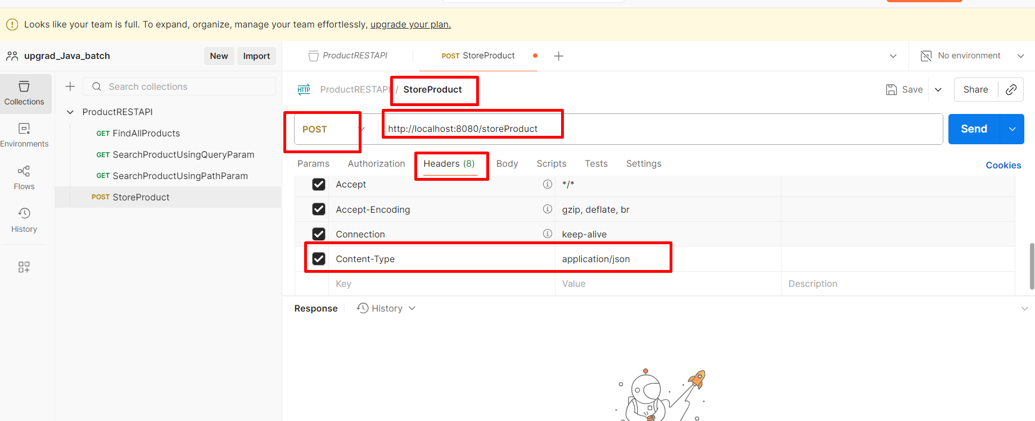

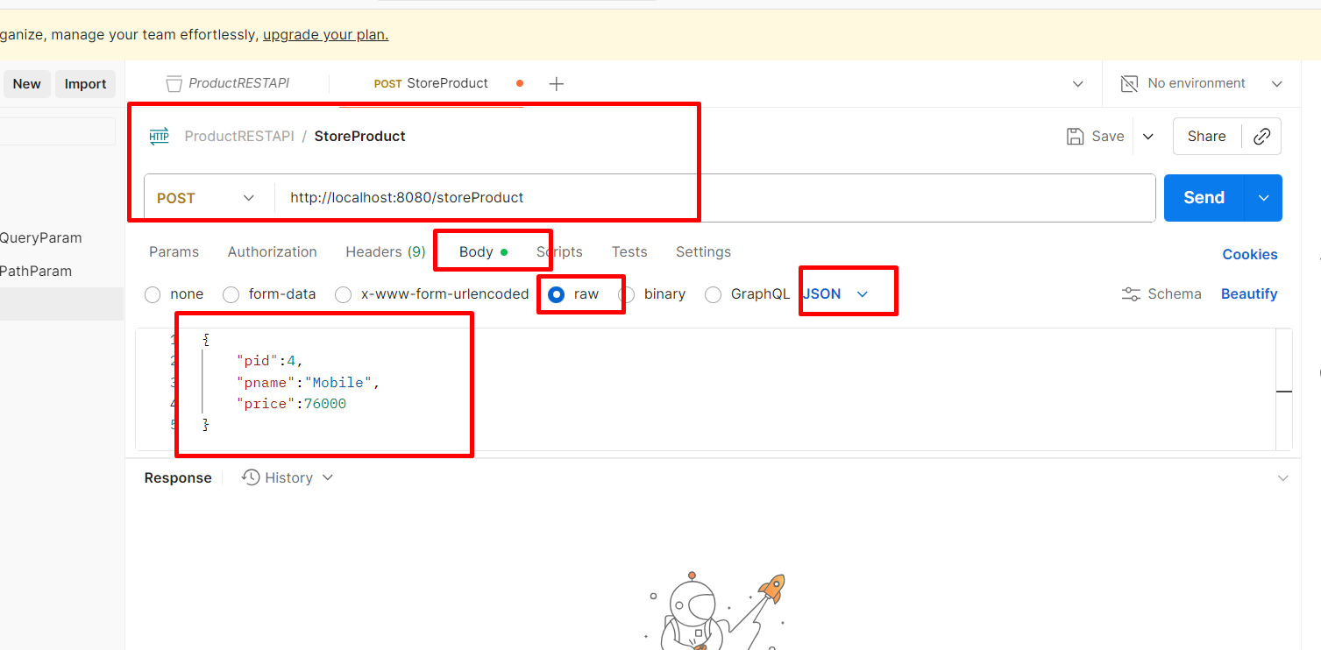

Put Method or Patch method
Delete method

To check rest api we can use rest api plugin
Post Man Client

